Script to Find Login with No Permission – SQL Server
http://www.sqldbaexperts.com/script-to-find-login-with-no-permission-sql-server/
Have you ever came across situation where you have to identify user which has no permission on SQL server. If yes, then below script will be useful for you. Below script gives you list of user who has no Permission on SQL server.
SET NOCOUNT ON
CREATE TABLE #all_users (db VARCHAR(70), sid VARBINARY(85), stat VARCHAR(50))
EXEC master.sys.sp_msforeachdb
'INSERT INTO #all_users
SELECT ''?'', CONVERT(varbinary(85), sid) ,
CASE WHEN r.role_principal_id IS NULL AND p.major_id IS NULL
THEN ''no_db_permissions'' ELSE ''db_user'' END
FROM [?].sys.database_principals u LEFT JOIN [?].sys.database_permissions p
ON u.principal_id = p.grantee_principal_id
AND p.permission_name <> ''CONNECT''
LEFT JOIN [?].sys.database_role_members r
ON u.principal_id = r.member_principal_id
WHERE u.SID IS NOT NULL AND u.type_desc <> ''DATABASE_ROLE'''
IF EXISTS
(SELECT l.name FROM sys.server_principals l LEFT JOIN sys.server_permissions p
ON l.principal_id = p.grantee_principal_id
AND p.permission_name <> 'CONNECT SQL'
LEFT JOIN sys.server_role_members r
ON l.principal_id = r.member_principal_id
LEFT JOIN #all_users u
ON l.sid= u.sid
WHERE r.role_principal_id IS NULL AND l.type_desc <> 'SERVER_ROLE'
AND p.major_id IS NULL
)
BEGIN
SELECT DISTINCT l.name LoginName, l.type_desc, l.is_disabled,
ISNULL(u.stat + ', but is user in ' + u.db +' DB', 'no_db_users') db_perms,
CASE WHEN p.major_id IS NULL AND r.role_principal_id IS NULL
THEN 'no_srv_permissions' ELSE 'na' END srv_perms
FROM sys.server_principals l LEFT JOIN sys.server_permissions p
ON l.principal_id = p.grantee_principal_id
AND p.permission_name <> 'CONNECT SQL'
LEFT JOIN sys.server_role_members r
ON l.principal_id = r.member_principal_id
LEFT JOIN #all_users u
ON l.sid= u.sid
WHERE l.type_desc <> 'SERVER_ROLE'
AND ((u.db IS NULL AND p.major_id IS NULL
AND r.role_principal_id IS NULL )
OR (u.stat = 'no_db_permissions' AND p.major_id IS NULL
AND r.role_principal_id IS NULL))
ORDER BY 1, 4
END
DROP TABLE #all_users
You will get the result as below, where Guest user has no Database level permission and not even any server level permission.
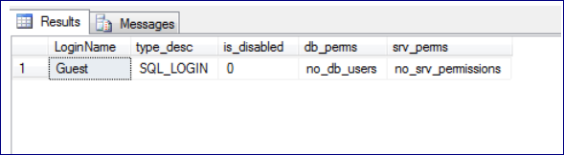
Try running the script and let me know if you get the expected result.

